Ex.no:9 | MINI PROJECT – FINANCIAL  DATA ANALYTICS

Aim:
To clean, transform, store, and analyze Financial transaction data using Python, MySQL, Power BI and Tableau to derive meaningful insights into transaction trends, customer transactions, account types, transaction types, transaction amounts, states, banking channels, loan information, transaction status, and fraudulent transactions.

Algorithm:
- Load the Indian banking transaction dataset from the CSV file using Pandas.
- Clean the data by handling missing values, removing duplicate records, and eliminating unnecessary attributes.
- Transform the data by standardizing column names and creating useful derived fields such as transaction amount, account balance, transaction hour, and fraud indicators.
- Store the cleaned and transformed dataset in a MySQL database named financial_analytics.
- Connect the MySQL database to Power BI for data analysis and reporting.
- Create DAX measures for key metrics such as total transactions, total transaction amount, average transaction amount, total fraudulent transactions, and average account balance.
- Develop interactive visualizations to analyze transaction trends, account types, transaction types, states, banking channels, loan information, and fraudulent transactions.
- Generate business insights from the Power BI & Tableau dashboard.
- End the process.

Architecture:

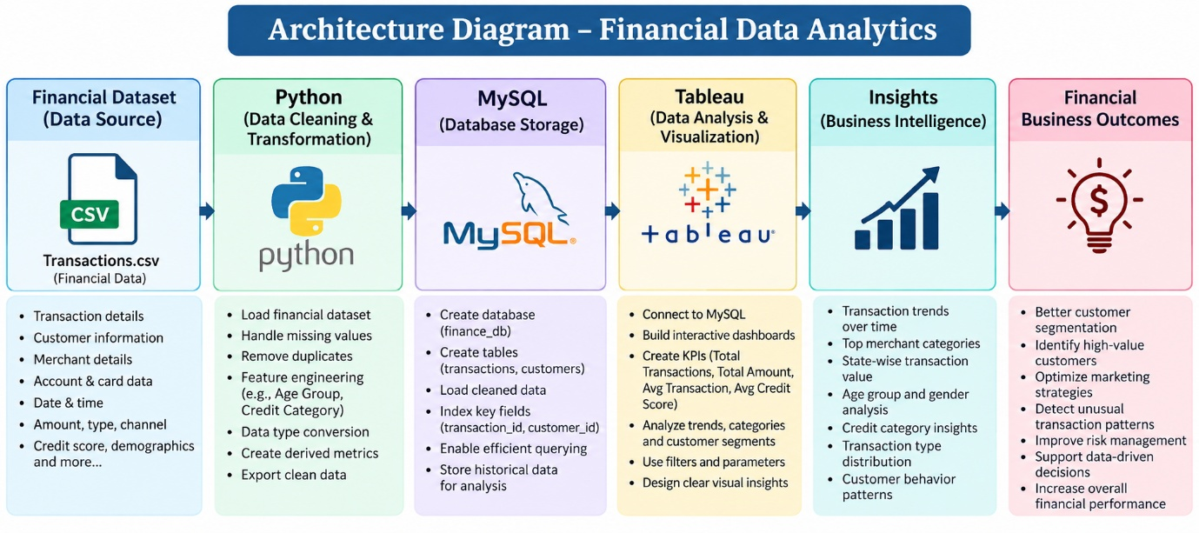

Program:
1. Python – Data Cleaning & Transformation
import pandas as pd
from sqlalchemy import create_engine, text

# Load dataset
df = pd.read_csv("indian_banking_transactions.csv")

# Create a copy for processing
financial = df.copy()

# Remove duplicate records
financial.drop_duplicates(inplace=True)

# Handle missing values
financial["loan_type"] = financial["loan_type"].fillna("No Loan")

# Convert date column
financial["transaction_date"] = pd.to_datetime(
financial["transaction_date"],
errors="coerce"
)

# Convert numerical columns
financial["transaction_amount"] = pd.to_numeric(
financial["transaction_amount"],
errors="coerce"
)

financial["account_balance"] = pd.to_numeric(
financial["account_balance"],
errors="coerce"
)

financial["credit_score"] = pd.to_numeric(
financial["credit_score"],
errors="coerce"
)

financial["emi_amount"] = pd.to_numeric(
financial["emi_amount"],
errors="coerce"
)

# Fill missing numerical values
financial["transaction_amount"] = financial["transaction_amount"].fillna(0)
financial["account_balance"] = financial["account_balance"].fillna(0)
financial["credit_score"] = financial["credit_score"].fillna(0)
financial["emi_amount"] = financial["emi_amount"].fillna(0)

# Standardize column names
financial.columns = (
financial.columns
.str.lower()
.str.strip()
.str.replace(" ", "_")
)

# Display dataset information
print("Original Shape:", df.shape)
print("Cleaned Shape:", financial.shape)
print(financial.head())

2. MySQL – Database and Data Loading
MySQL Command Prompt:
net start MySQL80
mysql -u root -p
MySQL:
CREATE DATABASE IF NOT EXISTS financial_analytics;
Python/Jupyter:
username = "root"
password = "YOUR_MYSQL_PASSWORD"
host = "localhost"
port = 3306

# Connect to MySQL database
db_engine = create_engine(
f"mysql+pymysql://{username}:{password}@{host}:{port}/financial_analytics"
)

# Load cleaned data into MySQL
financial.to_sql(
"banking_transactions",
con=db_engine,
if_exists="replace",
index=False,
chunksize=5000
)

print("Data loaded successfully into MySQL.")

Verify:
pd.read_sql(
"SELECT COUNT(*) AS total_rows FROM banking_transactions",
db_engine
)
3. Power BI – DAX Measures
Total Transactions = DISTINCTCOUNT(banking_transactions[transaction_id])

Total Transaction Amount = SUM(banking_transactions[transaction_amount])

Average Transaction Amount =AVERAGE(banking_transactions[transaction_amount])

Average Account Balance =AVERAGE(banking_transactions[account_balance])

Successful Transactions =CALCULATE(COUNTROWS(banking_transactions),
banking_transactions[transaction_status] = "Success")

4. Tableau Dashboard
Created visuals in tableau in separate sheets and created a dashboard

Output:
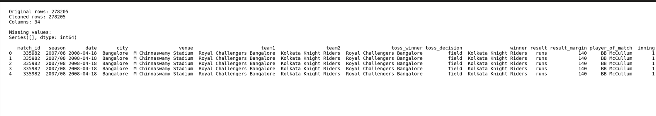

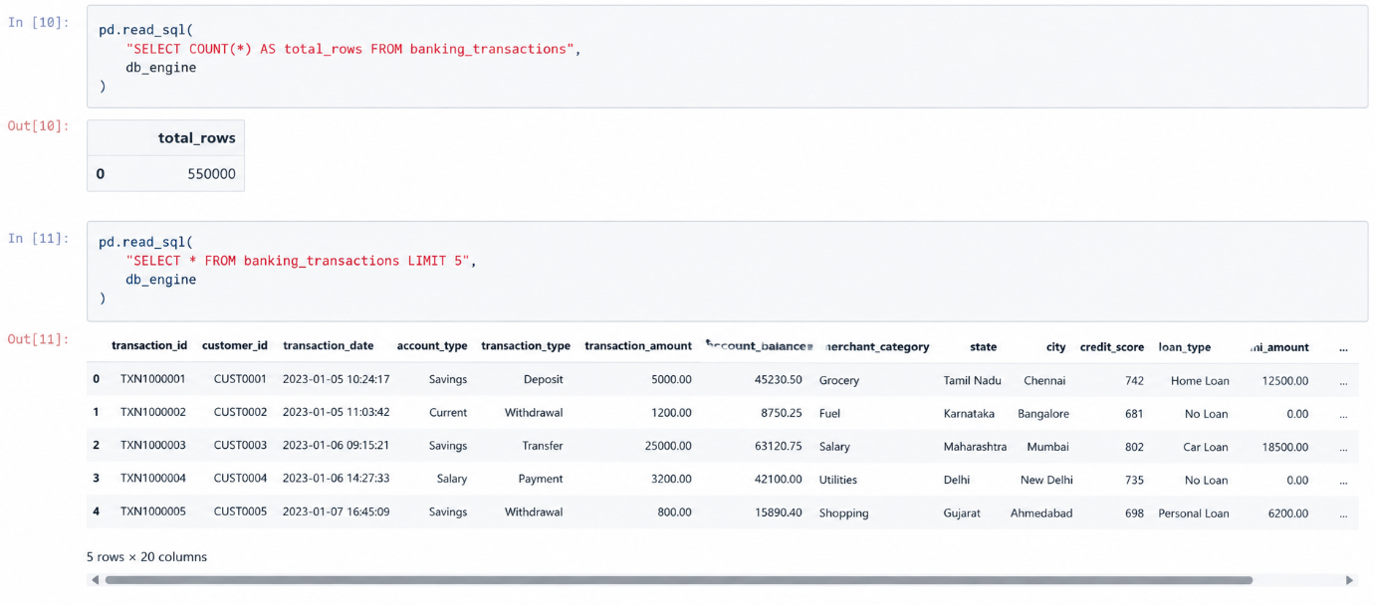

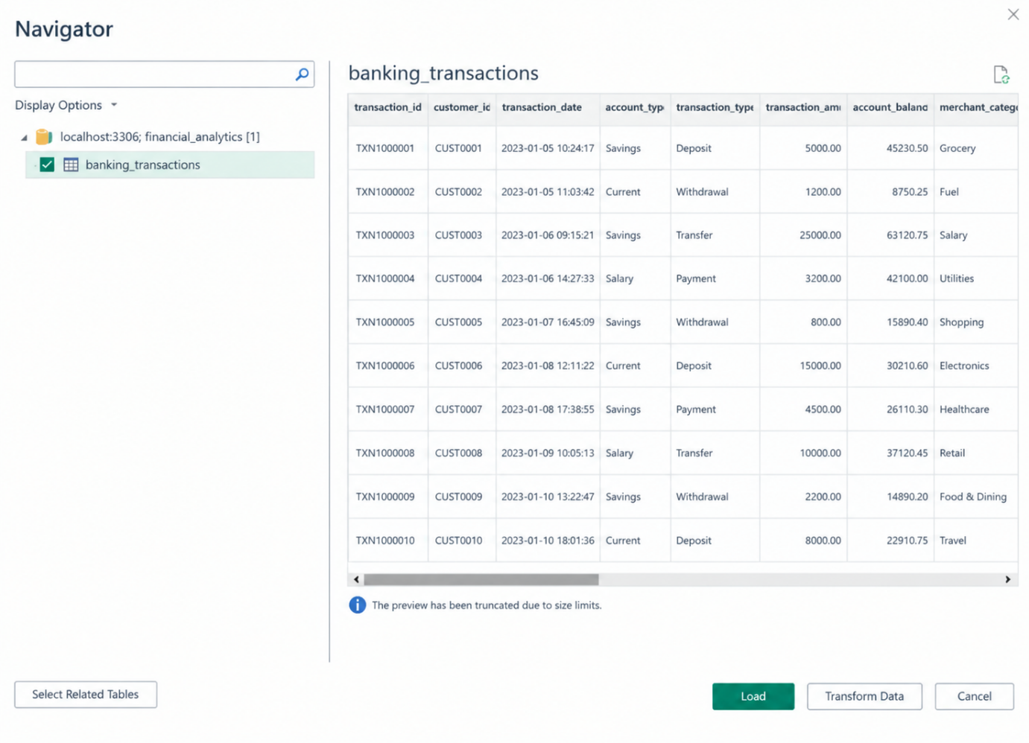

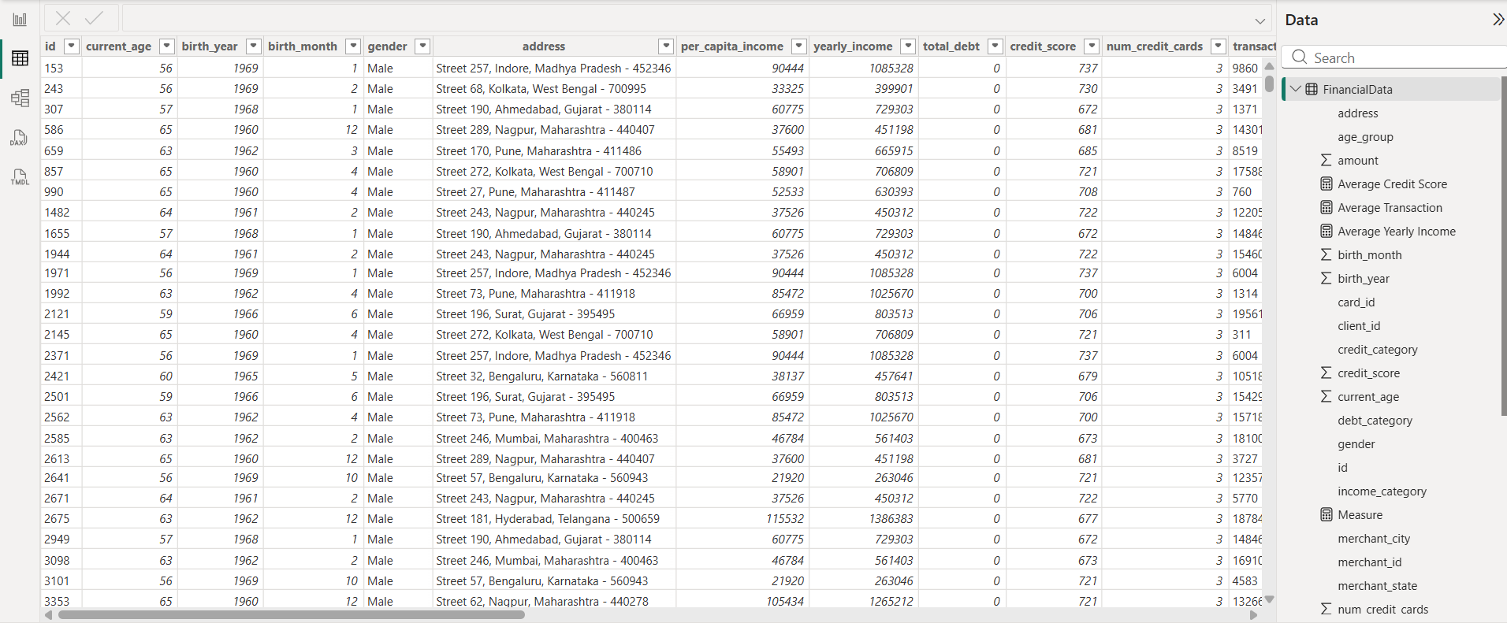

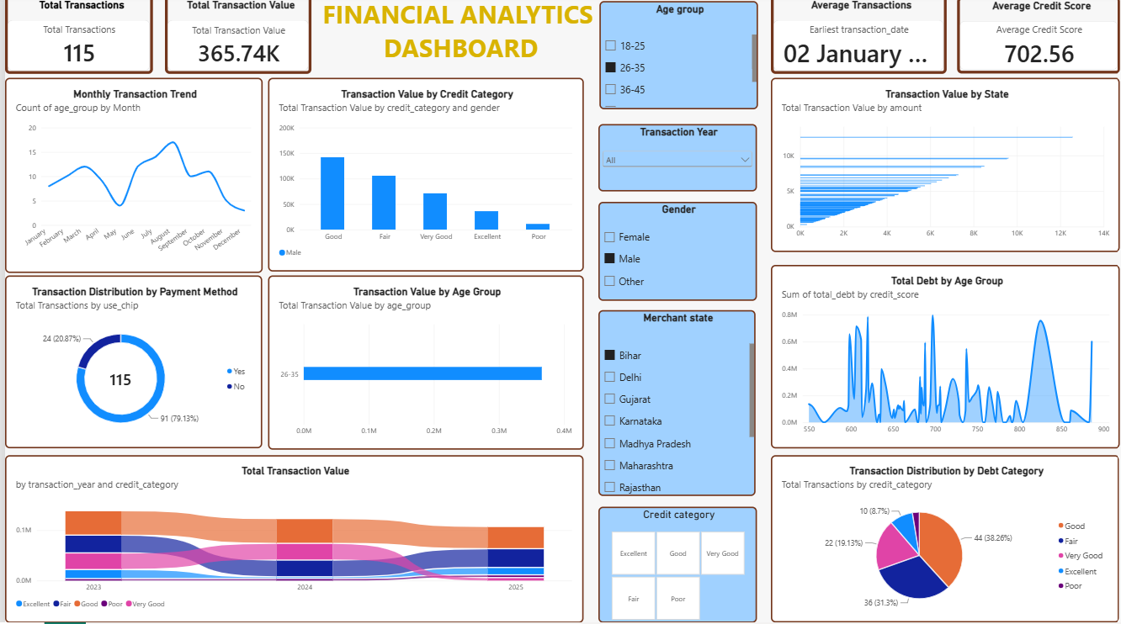

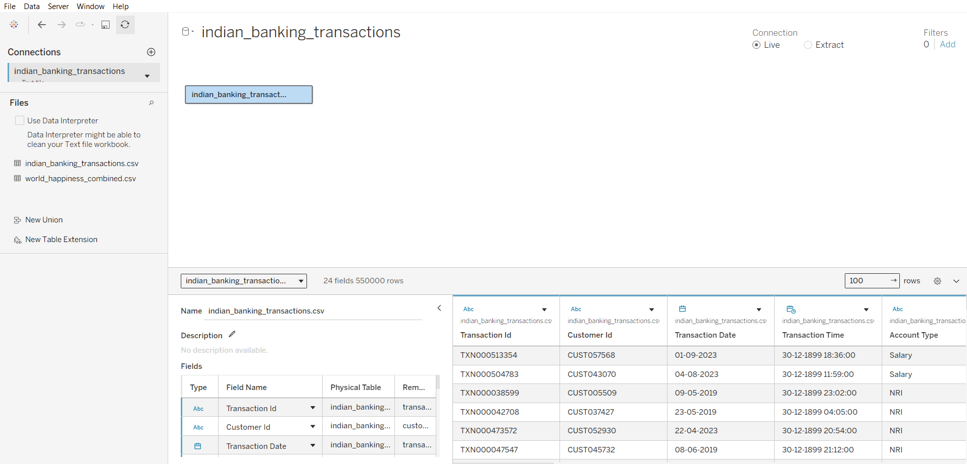

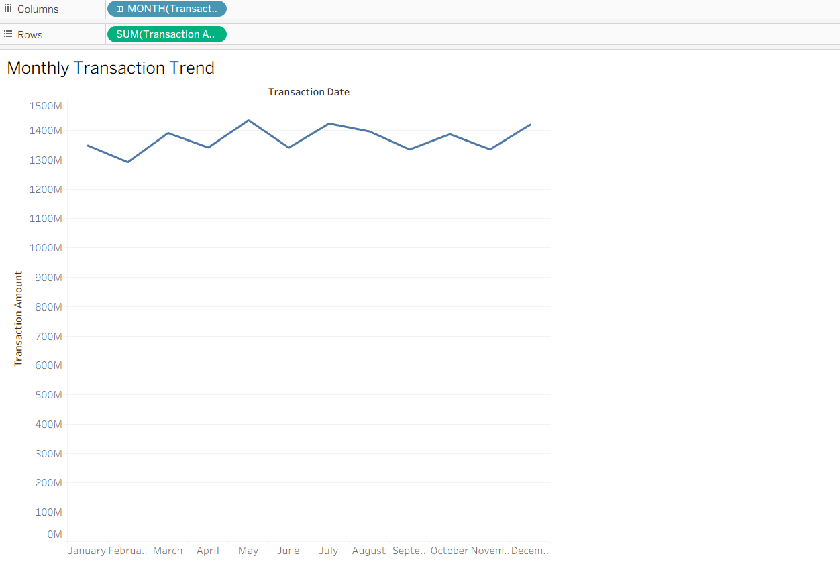

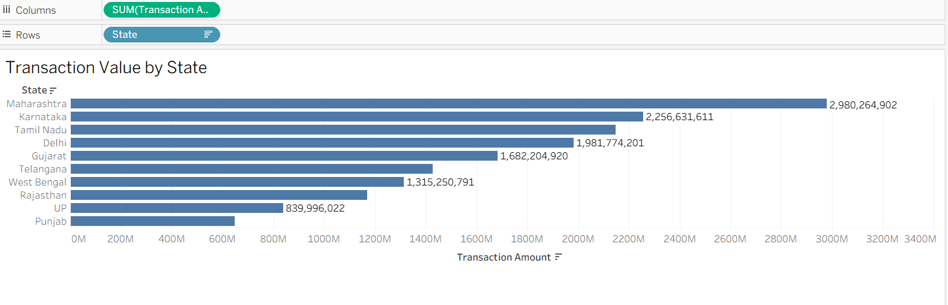

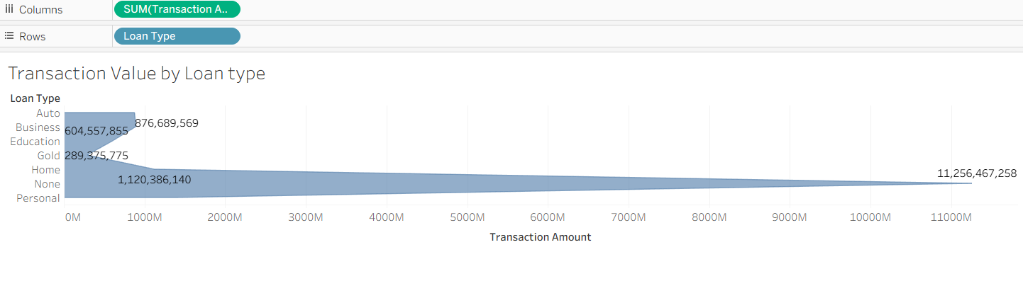
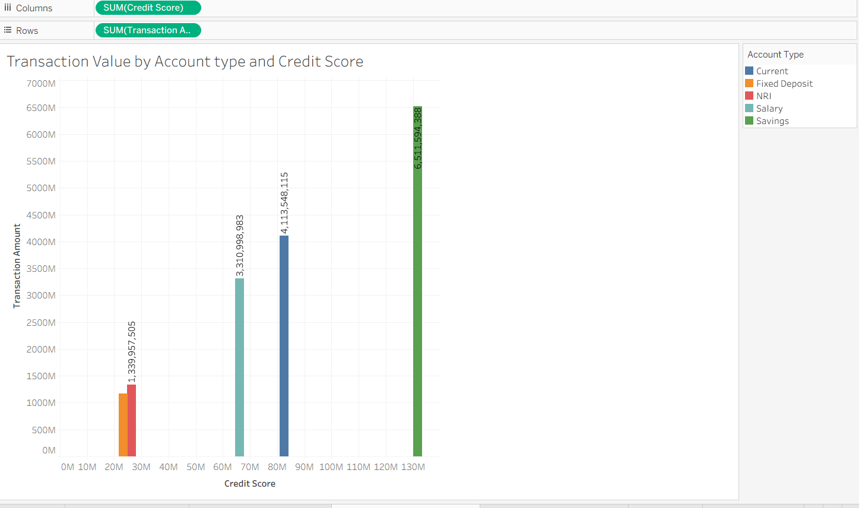

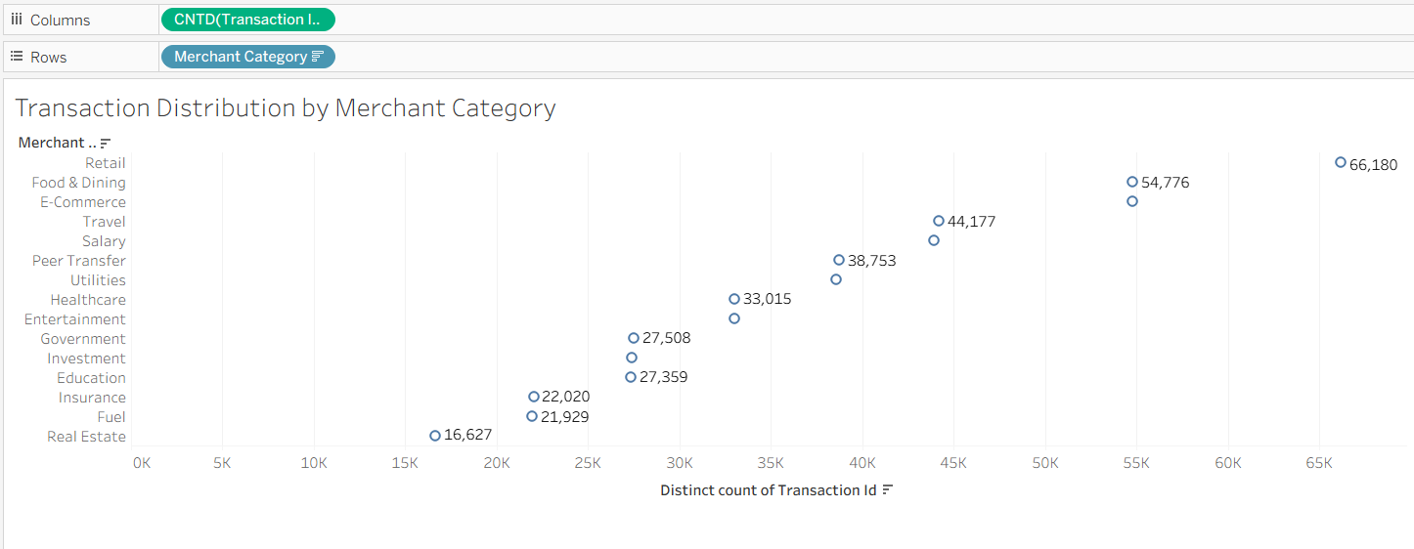

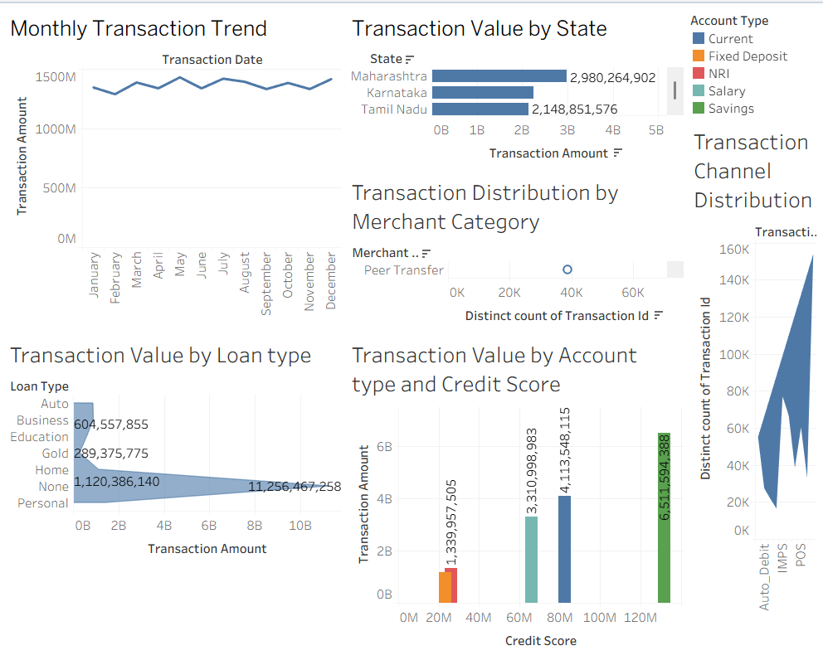

Result:

